# 

# 

# Large Synoptic Survey Telescope (LSST)

Risk & Opportunity Management Report

August 2020

Austin Roberts

Document-36465

Latest Revision Date: September 2, 2020

Change Record

|  |  |  |  |
| --- | --- | --- | --- |
| **Version** | **Date** | **Description** | **Owner name** |
| 1.0 | September 2, 2020 | Initial Writing | A. Roberts |
|  |  |  |  |
|  |  |  |  |
|  |  |  |  |
|  |  |  |  |
|  |  |  |  |
|  |  |  |  |
|  |  |  |  |
|  |  |  |  |
|  |  |  |  |
|  |  |  |  |
|  |  |  |  |
|  |  |  |  |
|  |  |  |  |

Table of Contents

Change Record i

Summary iii

Applicable Documents iii

Reference Documents iii

1 Brief Narrative 1

2 Subsystem Risk and Opportunity Exposure Summary 1

3 Top Ten Lists 3

3.1 Risk Registry Top Ten List 3

3.2 Opportunity Registry Top Ten List 5

4 Probability vs Cost Exposure 5x5 Matrix 6

5 Six Month Trigger Date Outlook 8

6 Risk Exposure Trending 12

7 Monte Carlo Analysis 13

8 Summary of Monthly Entry Changes 15

9 Special COVID-19 Risks 30

# Risk and Opportunity Management Report

# Summary

This report summarizes the changes made to the Risk and Opportunity Register for the specified time period. The report also includes information on the top risks as determined by Probability Weighted Cost Exposure and those deemed critical (red) risks on the typical 5x5 matrix; the report also provides summary statistics for each subsystem, reviews risks and mitigations for entries with upcoming trigger dates, provides trending information, and summaries changes made during the month.

Items colored in blue indicate a change from the previous month.

# Applicable Documents

# Reference Documents

# Risk and Opportunity Management Report – August 2020

# Brief Narrative

The Jira tool functionality was further expanded with additional scripts and dashboards for more streamlined management. By expanding the tool and providing training on its usage, subsystems will have an increased ability to view, analyze, and manage their risks. The tool will therefore lead to an increased visibility on risk exposure at various project levels. In addition to risks and opportunities, this has allowed us to focus on discrete mitigating actions, an estimate of how these actions will reduce our current expose levels, and capturing anticipated completion dates of these mitigating actions. As these mitigating actions are completed, the exposure of the associated risks is re-evaluated against this estimate. We now also have the ability to report what our probability weighted cost exposure after the final mitigations are completed is expected to be with our Monte Carlo script.

The overall R&O Probability Weighted Cost Exposure (PWCE) decreased from **$XX.XXM** to **$XX.XXM**.

The overall R&O Probability Weighted Cost Exposure (PWCE) after final mitigations decreased from **$XX.XXM** to **$XX.XXM**.

**1.1 High Level Summary of Monthly Changes**

We are now focusing on schedule-based reviews for risks with upcoming trigger dates and/or upcoming mitigating actions anticipated to complete. This month with the new PWCE after mitigation functionality, we focused on entering anticipated completion dates and the expected risk reduction on mitigating actions.

Given the situation with the COVID-19 pandemic we have added a table of the risks that have been identified specifically related to the impact of the pandemic in Section 9. These risks are not included in the calculations or Monte Carlo analysis.

A more detailed summary of the changes made this period is documented in Section 8.

# Subsystem Risk and Opportunity Exposure Summary

The following tables summarize the Probability Weighted Cost Exposure for each subsystem as well as the state of each of their risks and opportunity entries. Changes from the previous month are shown in blue.

Table : Summary of Risk Exposure

|  |  |  |  |  |  |  |  |  |
| --- | --- | --- | --- | --- | --- | --- | --- | --- |
| **Sub-system** | **Active Risk/Opportunity** | **Proposed** | **Realized** | **Retired** | **Expected Labor Risk Exposure (K-USD)\*** | **Expected Non-Labor Risk Exposure** | **Prob. Weighted Exposure Cost (K-USD)\*** | **Prob. Weighted Exposure Cost After Mitigation (K-USD)\*** |
| **Data Management** | 60 | 1 | 6 | 23 | 0 | 0 | 0 | 0 |
| **Education and Public Outreach** | 7 | 2 | 1 | 8 | 0 | 0 | 0 | 0 |
| **Project Management Office** | 13 | 11 | 0 | 2 | 0 | 0 | 0 | 0 |
| **Systems Engineering** | 22 | 2 | 2 | 11 | 0 | 0 | 0 | 0 |
| **Telescope & Site** | 58 | 4 | 3 | 25 | 0 | 0 | 0 | 0 |
| **Totals** | **160** | **20** | **12** | **69** | **0** | **0** | **0** | **0** |

Table : Summary of Opportunity Exposure

|  |  |  |  |  |  |  |  |
| --- | --- | --- | --- | --- | --- | --- | --- |
| **Sub-system** | **Active Risk/Opportunity** | **Proposed** | **Realized** | **Retired** | **Expected Labor Risk Exposure (K-USD)\*** | **Expected Non-Labor Risk Exposure** | **Prob. Weighted Exposure Cost (K-USD)\*** |
| **Data Management** | 1 | 0 | 0 | 4 |  |  | 0 |
| **Education and Public Outreach** | 0 | 0 | 2 | 0 |  |  | 0 |
| **Project Management Office** | 5 | 0 | 0 | 2 |  |  | 0 |
| **Systems Engineering** | 3 | 0 | 0 | 1 |  |  | 0 |
| **Telescope & Site** | 0 | 0 | 0 | 0 |  |  | 0 |
| **Totals** | **9** | **0** | **2** | **7** |  |  | **0** |

# Top Ten Lists

## 3.1 Risk Registry Top Ten List

As of September 2, 2020, the Risk & Opportunity Registry contains 160 active risk entries. The following list contains the top 10 risks as evaluated by the probability weighted cost exposure in JIRA. The top ten are tracked closely as having potential contingency impact.

Table : Risk Registry Top Ten List

|  |  |  |  |  |  |  |
| --- | --- | --- | --- | --- | --- | --- |
| **Top Risks List** | | | | | | |
| **Sort Number** | **Risk ID (Parent)** | **Subsystem** | **WBS** | **Risk Title** | **Probability Weighted Cost Exposure ($K)** | **Probability Weighted Cost Exposure After Mitigation ($K)** |
| 1 | RM-886 | Project Management Office | 01C | Example | 0 | 0 |
| 2 | RM-888 | Project Management Office | 01C | Example | 0 | 0 |
| 3 | RM-817(P) | Telescope & Site | 4.5 | Example | 0 | 0 |
| 4 |  |  |  |  |  |  |
| 5 |  |  |  |  |  |  |
| 6 |  |  |  |  |  |  |
| 7 |  |  |  |  |  |  |
| 8 |  |  |  |  |  |  |
| 9 |  |  |  |  |  |  |
| 10 |  |  |  |  |  |  |
|  | **Date:** | **9/2/2020** |  | **Top Ten Total:** | **0** | **0** |

## 3.2 Opportunity Registry Top Ten List

As of September 2, 2020, the Risk & Opportunity Registry contains 9 active opportunity entries.

The following list contains the top 10 opportunities as evaluated by the probability weighted cost exposure in the Opportunity Register.

Table : Opportunity Registry Top Ten List

|  |  |  |  |  |  |
| --- | --- | --- | --- | --- | --- |
| **Top 10 List - Opportunities** | | | | | |
| **Sort Number** | **Opp ID #** | **Subsystem** | **WBS** | **Title** | **Probability Weighted Cost Exposure ($K)** |
| 1 | RM-628 | Project Management Office | 1.01C.01 | Example | 0 |
| 2 |  |  |  |  |  |
| 3 |  |  |  |  |  |
| 4 |  |  |  |  |  |
| 5 |  |  |  |  |  |
| 6 |  |  |  |  |  |
| 7 |  |  |  |  |  |
| 8 |  |  |  |  |  |
| 9 |  |  |  |  |  |
| 10 |  |  |  |  |  |
|  | **Date:** | **9/2/2020** |  | ***Top Ten Total:*** |  |

# Probability vs Cost Exposure 5x5 Matrix

Each of the active risks have been sorted and binned in the following 5 x 5 matrix.

**Table 5: 5 x 5 Matrix**

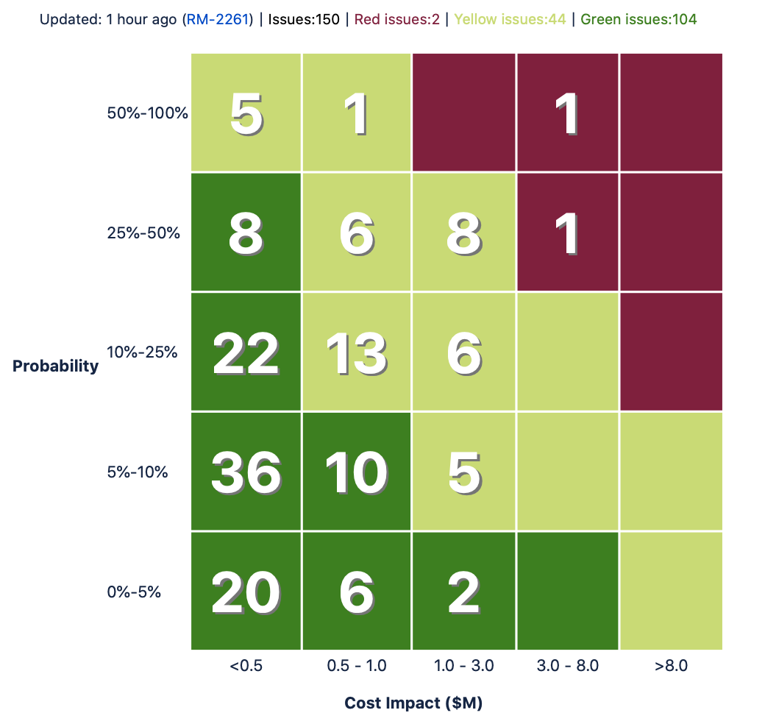

The number of critical (red) risks decreased from 3 to 2. The risks that are in the critical range (red in Table 5) are shown in the following table.

**Table 6: Critical Risks List**

|  |  |  |  |  |  |  |
| --- | --- | --- | --- | --- | --- | --- |
| **Risk ID (Parent)** | **Subsystem** | **WBS** | **Summary** | **PWE ($K)** | **PWE After Mitigation ($K)** | **Proposed Management Response** |
| RM-886 | Project Management Office | 01C | Example | 0 | 0 |  |
| RM-888 | Project Management Office | 01C | Example 2 | 0 | 0 |  |

# Six Month Trigger Date Outlook

As of September 2, 2020 there were 52 risks with trigger dates in the next 6 months or past due. Table 7 summarizes those entries. Each of these risks have notes included in their entries describing the activities that will occur in the near term and the response needed if they are to materialize.

Table : Six Month Trigger Date Report

|  |  |  |  |  |  |  |  |  |  |
| --- | --- | --- | --- | --- | --- | --- | --- | --- | --- |
| Subsystem | Risk ID (Parent) | Summary | WBS | Trigger Date | Probability | Nonlabor Cost | Labor Cost | PWE ($K) | PWE After Mitigation ($K) |
| Telescope & Site | RM-1938 | Example | 04C.04.02.05 | 30/09/2020 | 25%-50% | 0 | 0 | 0 | 0 |

# Risk Exposure Trending

Figure 1 shows the time history of the Probability Weighted Cost Exposure of Risks for each subsystem and the project as a whole. These changes are explained in more detail in the Brief Narrative section.

Figure : Probability Weighted Cost Exposure Time History

# Monte Carlo Analysis

The following charts summarize the Monte Carlo Analysis conducted on September 2, 2020, consisting of 500 iterations.

|  |  |
| --- | --- |
|  |  |
|  |  |

The following table shows the risk exposure at several confidence levels.

|  |  |  |  |  |
| --- | --- | --- | --- | --- |
| **Confidence Level** | **Cost (then-year)**  **This Period** | **Cost (then-year)**  **Previous Period** | **Cost After Mitigations (then-year)**  **This Period** | **Cost After Mitigations (then-year)**  **Previous Period** |
| 50% | $XX.XXM | $XX.XXM | $XX.XXM | $XX.XXM |
| 70% | $XX.XXM | $XX.XXM | $XX.XXM | $XX.XXM |
| 80% | $XX.XXM | $XX.XXM | $XX.XXM | $XX.XXM |
| 90% | $XX.XXM | $XX.XXM | $XX.XXM | $XX.XXM |
| 99% | $XX.XXM | $XX.XXM | $XX.XXM | $XX.XXM |

# 

# Summary of Monthly Entry Changes

|  |  |  |  |  |  |
| --- | --- | --- | --- | --- | --- |
| ID | Date | Author | Field | From | To |
| RM-1932 | 2020-08-28 21:04:35 | Chuck Claver | Obligation Date | 7/Sep/20 | 1/Feb/21 |
| RM-739 | 2020-08-05 18:44:08 | Chuck Claver | Obligation Date | 1/Aug/20 | 30/Oct/20 |
| 2020-08-05 18:45:25 | Chuck Claver | General Notebook 1 | Some text | Some new text |

# Special COVID-19 Risks

|  |  |  |
| --- | --- | --- |
| Risk ID | Risk Title | Risk Description |
| **RM-1969** | **Example** | IF … THEN …. |